**Performance Report V.1.0**

**COGS Report Management**

**Version History**

|  |  |  |  |  |
| --- | --- | --- | --- | --- |
| **Date** | **Version** | **Author/QA** | **QA Manager/ Architect** | **Description** |
| 27.10.2018 | 1.0 | Shahbaz Qaiser/ Abu Zohran | Ahmed Bilal / Eliya | Performance Report |

**Performance Testing Report**

**Thread Properties**

1. Virtual Users O5
2. Ramp up 01 sec.
3. Loop Count 01

**API’s**

1. Get Managers (For Leave Reporting)
2. Get Timesheet Summary (For Leave Reporting)
3. Get Employee Skills Report
4. Get Info Directory (For Pulse Reporting)
5. Get Project Pulse Report (For Pulse Reporting)
6. Get Bravo Report
7. Get Project Costing Report
8. Get Project Bonus Report

**Response Time Graph:**

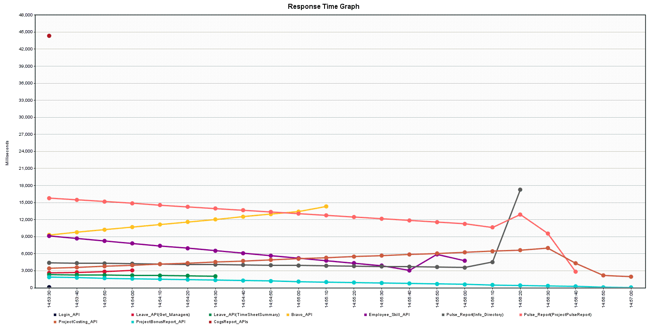

**Result Data**

CSV file shared in folder.